InsideBU
Autumn 2015

[Heading One] Contents page

Page 2: Fusion Investment Fund/Take your BU degree global adverts

Page 3: Contents and message from John Vinney

Pages 4 – 5: News from around BU/Chloe’s Column

Pages 6 – 7: Where are they now?

Pages 8 – 9: The pen is mightier than the sword

Page 10: A student story of an underwater Equador

Page 11: Vice-Chancellor’s Staff Awards 2015

Pages 12 – 13: BU students go global

Pages 14 – 15: We Meet…Tara Douglas and Dr Bronwen Thomas

Pages 16 – 17: BU’s research goes global

Pages 18 – 19: Introducing your global BU

Page 20: Voice of Vietnam

[Heading Two] Message from John Vinney, Vice-Chancellor
Welcome to the latest edition of InsideBU – the magazine that keeps BU’s community of students and staff up to date with what’s going on around the university.

This issue looks at the different ways BU is going global, under the leadership of Dr Sonal Minocha, Pro Vice-Chancellor for Global Engagement. It comes at a time when BU has entered the elite Times Higher Education top 500 universities in the world for the first time.

Now that we’re underway with another academic year, I’d like to welcome all the new students and staff, with a particular mention to our international students who joined us at the inaugural international commencement ceremony recently. I’m really proud to say that BU is the only UK University to welcome its new international students in this way and you can read more about it on page 5.

With global engagement at the heart of our powerful fusion of research, education and professional practice, it’s fantastic to see BU’s global community continually expanding. You can find out more about our ambitions for Global Fusion on page 18, where Sonal talks about our exciting plans for the future.

I hope you enjoy this issue and if you feel inspired to share your ideas about the topics raised please email globalbu@bournemouth.ac.uk.

[Heading Three] News from around BU
[Sub-heading] Bournemouth University International College Opens
The Bournemouth University International College on the Lansdowne Campus opened its doors to students and staff in September 2015.

The building – an educational collaboration between BU and Kaplan International Colleges – will eventually welcome up to 600 international students every year. It will offer preparation programmes which will give students the academic and English language skills to go on and study undergraduate and postgraduate degrees at BU.

The Bournemouth University International College – now the highest building in Bournemouth – has panoramic views out to the Isle of Wight, Old Harry Rocks, the Purbecks and the New Forest. It will host opportunities for shared learning such as workshops, guest talks, film nights, clubs and societies.

The building was officially opened by the Mayor of Bournemouth in October. To find out more, head to www.kic.org.uk/bournemouth.

[Sub-heading] Global Buddies
September saw the launch of Global BUddies - a new project which matches new students in small groups with someone of a different nationality.

It aims to increase integration between UK students and international students on campus, helping students to build a network of new friends from all over the world and develop valuable skills in the process.

For more information, visit www.bournemouth.ac.uk/ global-buddies.

[Sub-heading] BU students take part in the Salzburg Academy
Over the summer BU students joined over 70 others from 20 countries at the Salzburg Academy on Media and Global Change, to discuss how digital media can tackle issues of local and global concern.

With the United Nations Development Program, the Red Cross Red Crescent Climate Centre and Global Voices – and led by academic, development and media experts – the students sought to develop innovative media tools to better understand media literacy and address challenges from climate change to women’s rights.

Find out more about the Salzburg Academy on Media and Global Change at media-academy.salzburgglobal.org.

[Sub-heading] BU on the up

BU has risen in four major University league rankings this year.

Following three UK league table rises in 2015, the university has now entered the ranks of the top 500 universities in the world for the first time, according to the latest Times Higher Education World University Rankings. BU is one of only four post-92 UK institutions within the worldwide top 500, demonstrating the progress the university has made in recent years.

BU has also risen in all three major UK university league tables this year, with a rise of 11 places in the Complete University Guide to 54th nationally. A rise of six places in the Sunday Times Good University Guide takes BU from 88th to joint 82nd, while in the Guardian University League table 2016 BU was up eight places to 63rd nationally.

[Sub-heading] A warm #belongatBU welcome
Over 500 new BU international students enjoyed a very warm #belongatbu welcome from Professor John Vinney at the Bournemouth International Centre (BIC) at the start of the term.

Our new arrivals had the chance to talk to current students and alumni over dinner and drinks, and learn more about the UK and Dorset. The event was our first ever International Commencement Ceremony. Students found it particularly fitting to be starting their BU journey at the BIC, where they’ll be graduating in a few years’ time.

[Sub-heading] Associate Deans for Global Engagement
We’re pleased to welcome three new Associate Dean’s to BU’s Global Engagement team. They’ll lead the faculties through delivery of our plan to expand BU’s academic footprint and take it global.

• Dr Lucy Lu, Associate Dean - Global Engagement, Faculty of Management
• Dr Malcolm McIver, Associate Dean - Global Engagement, Faculty of Health & Social Sciences
• Dr Angelos Stefanidis, Associate Dean - Global Engagement, Faculty of Science & Technology
• The Associate Dean – Global Engagement for Faulty of Media & Communication will be announced soon
Meet the full Global Engagement team on the Staff Intranet: staffintranet.bournemouth.ac.uk/ aboutbu/globalengagement/ globalengagementteam

[Sub-heading] Celebrating NSS Success
Vice-Chancellor Professor John Vinney recently held a special event to recognise and celebrate the achievements of staff working on courses that performed particularly well in this year’s National Student Survey (NSS).

15 courses in total scored above the sector average while the Marketing, Physiotherapy and Social Work courses were presented with a ‘You’re Brilliant’ award by SUBU’s Vice-President Education Ellie Mayo-Ward, as they achieved overall student satisfaction scores of 100%.

Despite some outstanding results, BU will continue working towards higher student satisfaction levels to achieve greater consistency across all courses.

The NSS is a national survey, which asks UK final year undergraduate students how satisfied they are with various aspects of their studies. Results are publicly available to prospective students to help them make informed choices of where and what to study.

[Sub-heading] Chloe’s Column
SUBU has a whole range of cultural societies and networks from all over the world. They are great opportunities for the many cultures we have at BU to be able to integrate with each other, and for students to make friends globally. This year they came together to put on events such as One World Day, where the different cultural societies showcased where they were from by offering food samples from their countries and performing traditional dances.

At SUBU we’ve also elected International Officers – both EU and non-EU – who are here to represent our international student community at BU. This year they helped with the September and January inductions, giving talks to students about life at the university and meeting students at the International Welcome events. They’ve also been working on the Global BUddies scheme for new international students.
RAG, our fundraising arm provides a great opportunity for students to go global.

The challenges that RAG offer include Leggit, where students have 36 hours to hitchhike as far away from Bournemouth as possible, without spending a penny. Students travel all across Europe – with some even reaching the Sahara Desert! Other challenges that RAG offer include trekking Machu Picchu, building schools in Ghana, cycling London to Paris and the Barcelona Marathon.

Find out how you can get involved by heading to www.subu.org.uk

[Heading Four] Where are they now?
BU has a huge network of over 70,000 alumni, with over 11,000 living overseas. InsideBU finds out what some of them have been up to since graduating…

[Sub-heading] Aakanksha Devi, graduated in 2009 with a Master’s in Multimedia Journalism
Current location: India

As part of my degree, we were required to do an internship with a media house. I did two stints with the BBC initially, but India, where my family is from, gave me an opportunity to work on digital platforms for ESPN-Star-Sports. It’s the exposure to different cultures and people which ultimately gave me the confidence to take on any project.

Currently, I’m a senior reporter and assistant editor with The New Indian Express. I write and edit for a lifestyle weekly called Indulge – a glossy magazine. The job sees me living it up in Bangalore.

I believe that studying or working overseas drives home the point that you’re capable of adapting to a new situation which employers no doubt notice. It’s reassuring as an employer to know a person has worked in a place outside his or her comfort zone – it shows you’re confident enough to push boundaries and if you believe in yourself, others are almost obliged to follow suit!

Living abroad helps you look at things from a birds-eye point of view as you’re a bit of an outsider. It gives you a different perspective on things, which I find very stimulating and motivating. After all, you must prove yourself to others in these different lands!

[Sub-heading] Tijani Adavize, graduated in 2014 with a Master’s in Post-Production Editing
Current location: Nigeria
After completing my undergraduate degree in Nigeria, I still didn’t feel particularly confident in my abilities. I decided I needed to gain adequate skills that would give me the edge in a field I was passionate about – post-production editing.
BU was my number one choice, as the Faculty of Media & Communication was ranked highly and offered very specific courses, which is what I was after. The knowledge and skills I gained were invaluable; BU gave me confidence to trust my own abilities.

I now work as a Promo Producer at Television Continental News, a Pan- African TV station based in Lagos. I create promos for programmes as well as news items for the station; I do the final editing of every promo including adding sound effects, recording and adding voiceovers and logos before presenting the finished items to programme producers.

As well as the knowledge I gained at BU, I also improved my photography skills, something I’m really interested in. Now I’m no longer living in the UK, heading out to Bournemouth beach to take pictures is something I really miss!

[Sub-heading] Judit Maireder, graduated in 2005 with a Master’s in European Tourism Management
Current location: New Zealand
Gaining my Master’s overseas was key to my future career. My experiences fundamentally changed and influenced my career, my attitude, perspective and world view, including cultural understanding.

Part of my Master’s took place in Spain, so I lived and studied in Madrid as well as the UK as part of my degree. By living in two different countries during this time, I learnt something new every single day.

Since graduating I’ve worked in international media and advertising agencies around the world as a digital strategist, consulting international brands such as McDonalds, Visa, Rolex, Lufthansa and Air New Zealand, among others.

For the last four years I’ve been living in Auckland. At the start of this year I founded a brand and storytelling consultancy called Y Brand - www. ybrandconcept.com. We work with a network of creators and researchers helping brands to find their purpose.

I truly believe that studying and living abroad broadened my perspective and helped me understand different cultures - an advantage in business as well as my personal life.

[Heading Five] The pen is mightier than the sword

Dr Yeganeh Morakabati, an academic in the Faculty of Management, tells us about her time as a lecturer in Kabul – a story of apprehension, academia, alliances and armoured cars.

I’m the type of person who’s always keeping an eye open for new and exciting opportunities - wherever they may take me - so I was intrigued when I received an email from a university in Kabul asking if I would be interested in a short-term teaching position.

Education can change people’s lives and it’s my belief that those from poor countries need education more than anything else. Helping people from underprivileged areas is one of my passions, so I immediately applied for the role.

I was over the moon when I was offered the position. The reactions from friends and colleagues were mixed but not entirely unexpected – they thought I was either brave or crazy. The security situation in Afghanistan stops most of us wanting to go there and western education is prohibited by Taliban law. Being a female only makes its worse, but nothing could stop me from wanting to go.

Being picked up in a bullet-proof Land Cruiser at Kabul Airport was completely surreal. Although the streets were quiet and looked tired from the war, it also looked as though people were getting on and living their lives – and my life there was just starting.

I found my first couple of days teaching intense and exhausting. Aside from the unusual hours – 5am to 8am, followed by evening lessons – it was important I built the students’ trust, as their perception of teachers from overseas is that they may not be qualified to teach at degree level.

The concept of noise there is different and speaking over one another is part of the culture, so keeping them quiet long enough to engage them was challenging.

Slowly I built my relationship with them. Students there are very bright and read you well – they have to in order to survive in that environment. They were friendly and constantly challenged and questioned me, which I found refreshing. Although lessons started at dawn, they were always keen and well prepared. Most of my students had full-time jobs during the day and many had families to support.

I had preconceived ideas about Afghan culture and was proved wrong on many levels. For example, I assumed most young women would be married. However, the females I taught were in their 20s and single. More than that, you’d think in such a culture that girls would remain silent in a large crowd of noisy boys. But to my astonishment, far from encountering timid, shy girls, I found tigers standing before me making their presentations in English! These are the women of Afghanistan and I’m very proud to know them.

During my free time, I struck up a friendship with the lady who cleaned our apartment, and it was an amazing opportunity for me to learn first-hand about ‘ordinary’ life in extraordinary Kabul. She had lived through the Taliban regime and gone from living a comfortable life to becoming the main breadwinner for six children. Although many of her family had been killed during the war, she had such a soft soul and was so dignified and hardworking; her biggest wish was to see all of her children at university one day.

My trip has definitely changed me; I find teaching easier now, as working in such a challenging environment has increased my threshold. On a personal level, I grew significantly in confidence.

The war in Afghanistan has been costly in so many ways, although the loss of so many innocent lives dwarves the significance of any financial burden it may have placed on the taxpayer. But I believe it’s up to us to help build a more educated Afghanistan and since my experience teaching in a war-torn country, the old saying that ‘the pen is mightier than the sword’ has never been truer or had more meaning.

Find out more on Yeganeh’s blog: yegmorakabati.wordpress.com

[Heading Six] A student story of an underwater Ecuador
The BU Global Horizons Fund helps students to co-finance study-related activities overseas such as placements, volunteering projects and field trips. Applied Geography student Theo Clitherow shares his Ecuadorian experience.

Theo visited Santa Elena, a coastal region of Ecuador, as part of a Student Environmental Research Team project in marine conservation led by BU lecturer, Dr Rick Stafford.

As part of the scuba diving team, Theo explored coral reefs, rocky outcrops and mangroves, grouping together species like algae, noting different types of fish, the environment where they were found and the abundance of each species in each location.

“The main idea of the project,” Theo explains “was to create user-friendly predictive models for marine environment management, showing how local fishing, tourism and other human factors could influence marine species.”

Another way Theo helped the project was with his language skills, as none of the others in the project group spoke Spanish. “It’s one of my life ambitions to be fluent in Spanish so I’ve been on exchange trips and I also practice Spanish through conversation classes at BU. My language skills got us by, and I could explain to local dive guides what we needed, as well as general things, like sorting out where to live. It was good to talk to local fishermen to get their opinions on illegal fishing in nature reserves.”

Theo applied for Global Horizons Funding and was awarded £1,200. “The amount they gave me was really generous and it massively helped because I wouldn’t have been able to do this project without it”. Theo was also successful in getting an International Travel Grant award.

All BU students have the option of taking a placement during their course. “I’d say it’s the best thing about my course. Other people did marine conservation in Thailand, and various other places around the world. They’re really good experiences.”

When it comes to his future, Theo says “I want to go on to do a Master’s, so I thought this would be very useful way of putting everything I’ve learned into practice.”

Find out more about BU’s research at research.bournemouth.ac.uk Global Horizons Funding: www.bournemouth.ac.uk/globalhorizons

[Heading Seven] Vice-Chancellor’s Staff Awards 2015
This year’s Vice-Chancellor’s Staff Awards has seen more nominations than ever before. InsideBU reveals who has been shortlisted for all awards, including the brand new GlobalBU awards.

The Vice-Chancellor’s Staff Awards 2015 take place after an incredible year for the university. Since the previous Awards, BU has entered the world’s top 500 universities for the first time and risen in all three major UK league tables.

The fantastic new Student Centre and Bournemouth University International College have also opened to much acclaim in the last year.

All of this – and more besides - has been achieved thanks to the hard work and support of our staff.

The annual Staff Awards are an opportunity for us to celebrate the passion, achievements and professionalism of our staff; individuals and teams who really have gone that ‘extra mile’, perhaps for a particular project or on a daily basis; people who demonstrate service excellence in all they do.

[Subheading] Individual Achievement – Academic staff
• Professor Stella Fearnley, Faculty of Management
• Tom Goss, Kingston Maurward (Partner Institution)
• Professor Elizabeth Rosser, Faculty of Health & Social Sciences

[Subheading] Individual Achievement – Professional & Support staff
• Neil Goridge, Faculty of Media & Communications
• Sian Hedger, Marketing & Communications
• Paula Peckham, Faculty of Media & Communication

[Sub-heading] Unsung Hero – Academic staff
• Melanie Gray, Faculty of Media & Communication
• Chris Keenan, Centre for Excellence in Learning
• Dr Richard Scullion, Faculty of Media & Communications

[Sub-heading] Unsung Hero – Professional & Support staff
• Greta Danuleviciute, Marketing & Communications
• Nicola Marlow, Marketing & Communications
• David Stone, Marketing & Communications

[Sub-heading] Affiliate staff award
• Sue Burt, Chaplaincy
• Terri Lowther, Bright Horizons
• Shane Wilson, Chartwells

[Sub-heading] Collaborative team
• Faculty of Health & Social Sciences Widening Participation Steering Group
• International Admissions Team
• Peer Assisted Learning (PAL) Team

[Sub-heading] GlobalBU Award
Global engagement is a key part of the university’s strategy and our aim to become a world class university.
We want to recognise those who have been instrumental in significantly promoting global engagement while reflecting one or more of our values of excellence, achievement, authenticity, creativity and responsibility.

As a result, the very first GlobalBU award will be presented to an individual staff member, or to a team who may have inspired colleagues to engage globally, established global partnerships, supported internationalisation, taken an innovative and global approach to Fusion or enhanced BU’s reputation globally. Those shortlisted are:

• Kerry Leanne Berry, Faculty of Management
• Jill Davey, Faculty of Health & Social Sciences
• Dr Marta Vizcaya Echano, Academic Services

The winners of the Vice- Chancellor’s Staff Awards 2015 will be announced on the Student Portal and Staff Intranet shortly after the ceremony has taken place on Thursday 26 November.

[Heading Eight] BU students go global
Having the opportunity to work and study abroad or with international companies is something all our students can benefit from. InsideBU takes a look at some great examples of what’s possible when you challenge yourself.

[Sub-heading] Name: Glebs Kiselovs
Course: BA (Hons) Business Studies with Finance
Travelled to: New York, America
Funded by: Global Horizons Fund and working as a BU Student Ambassador

“In June 2015, I flew from my home in Latvia to the ‘Big Apple’ for a three day business trip. I was visiting to pitch a prototype I’d developed for American wood production company, Essay Group, after working with their UK offices. I was excited about my first ever trip to the USA and the opportunity to present my product to very influential people.

Overall the negotiations were challenging but I managed to impress them enough to be invited to take part in their UK exhibition in September 2015 to see how my idea could be put in to practice.

I now better understand how the theories and models I’d learned on my course work in the real world. This understanding and experience will give me a huge advantage on the rest of my course and in my future career. I definitely recommend everyone to work abroad because, who knows, it could be the start of your dream career.”

[Sub-heading] Name: Judith Munyakazi
Course: BA (Hons) Accounting & Finance
Studied in: Shanghai, China
Funded by:
£900 award from the Global Horizons Fund and fundraising activities

“Before starting my final year, I spent three weeks studying Mandarin at the East China Normal University in Shanghai as part of the ‘Study China Programme’. I have always been intrigued by China - the history, language and vibrant culture. I felt the experience of learning Mandarin would be much easier in the actual environment.

Attending lectures there gave me an insight to China’s foreign policies and business practices, and their influence on the society and economy.

The trip has been a benefit for my academic and professional career. The transferable skills I acquired, as well as learning Mandarin, will give me a competitive edge when applying for jobs. You get tenacity and develop adaptability with this type of experience, adding to your knowledge and confidence.

I’m now in Switzerland working as an intern in the financial communications department of global company Novartis Pharmaceuticals.”

[Sub-heading] Name: Chelsea Symes
Course: BA (Hons) Business Studies with Marketing
Studied in: Newfoundland, Canada
Funded by: Global Horizons Fund, student loan, and part-time work

“I spent nearly four months studying at Canada’s Memorial University in early 2015. It was a great opportunity to broaden my horizons, become more independent - and I loved being in a brand new environment.

In addition to my studies at BU, this experience helped me secure my 40-week placement in the marketing communications team at Farrow & Ball in the UK.
Studying abroad taught me how to brand, or portray, myself as a business student to employers. This will also help me after university - I now have something I can talk about really positively in interviews.

I definitely recommend studying abroad. It’s changed my perspective completely. I have become more organised and am definitely more independent as a person. Making friends with people from all around the world has taught me so much in many different ways.”

[Sub-heading] Name: Emilia-Jade Gibson
Course: BA (Hons) Marketing Communications
Worked for: Disney Destinations International in the UK

“My placement experience was a rollercoaster of highs and lows. The post I first applied for was made redundant after three months, but I was able to successfully secure a placement as a Digital Partnerships Marketing Coordinator with Disney.
I thought I was never going to get anywhere, but positivity, dedication and commitment got me a placement in both a global agency and a worldwide company and I wouldn’t have wanted it any other way.

Being in an international environment such as Disney has enabled me to learn so many new skills. Working for Walt Disney World, Disney Cruise Line and Disneyland Paris required me to liaise with team members in the US and Paris. I studied a unit in my second year called International Marketing Communications and it was great to put what I had learnt at university in to perspective on my placement year.

[Sub-heading] Name: Douglas Powell
Course: BSc (Hons) Product Design
Designed: A bicycle ambulance
Working with: Transaid (UK-based charity)

“After discovering a need for affordable rural transport in developing countries, I linked up with Transaid on a bicycle ambulance project. Our intention was for the product to be locally fabricated and used in communities as an ambulance, providing privacy and protection for the patient.

I eventually developed a prototype which the Managing Director from Transaid was blown away by - I donated it for Transaid to use in their summer shows to gain UK interest.

It will go to Zambia on an aid lorry in November to be properly tested. I hope to run a workshop next year with local fabricators, helping them build the trailer to the correct standards and teaching them about the design features. I’m immensely proud that a year’s worth of work is actually going to be genuinely useful to the people it was designed for.”

[Heading Nine] We Meet…
Tara Douglas is completing a professional doctorate with BU’s Centre for Digital Entertainment. Tara and her supervisor Dr Bronwen Thomas tell us about the research project, Tales of the Tribes.

[Sub-heading] Tara Douglas Research student, Faculty of Media & Communication
Tales of the Tribes is a series of five short animated folktales from North East and Central India.

It’s the first collection of animated films made in collaboration with Indigenous artists and young people in India. We’re working with them to translate and adapt their folktales for animation films, attempting to examine how animation can provide a tool to reconnect younger generations with their cultural heritage.

We’ve completed four films so far and one is still in production called Manjoor Jhali - the story of the Peacock. This story is from the Pardhan Gond community of Madhya Pradesh in Central India and is currently being animated by a small team of young animators from indigenous backgrounds with qualifications from the National Institute of Design.

This mythological story tells how the peacock was the most splendid creation of all and the moral of the story is to be content with what you have. As one of the artists from the Pardhan community related to it, it shows the message still has relevance for life lived in the village today. On the basis that such messages find wider resonance, this shows how folktales have transcended cultural boundaries.

Once the films have all been completed we’ll organise screenings. We hope audiences will recognise the modern-day value of indigenous cultural and artistic practices.

At the moment I’m finishing and submitting the Professional Doctorate thesis that accompanies this project, but in the future, I would like to continue this work to introduce animation as a tool for Indigenous artists and young people in India, perhaps with a long term aim of connecting minority cultures from different parts of the world through the medium of animation.

I’d also like to see a centre established in India to continue this work with Indigenous artists and young animators.

[Sub-heading] Dr Bronwen Thomas Associate Professor, Faculty of Media & Communication
Tara’s project is particularly important because she’s worked hard to include local artists in her work as a way of bridging the gap between traditional tribal cultures and the latest technology. Animation is a perfect tool for this as the artists’ depictions of characters and storylines from traditional tales work well not just for those already familiar with the tales, but for new audiences.

Tara was particularly keen to reach out to younger audiences, and to offer an alternative to the Disney/Pixar stories which are so dominant internationally. There have been challenges in producing the films: financial, cultural and political. While three of the films are now complete, others are still in production, so this project will be ongoing for many years to come.

Tara’s was one of the first projects to be supported by the Centre for Digital Entertainment, which focuses on research embedded in industry and engaging with the latest digital technologies. The programme has recently seen its first successful completions, and continues to attract innovative projects and highly skilled and motivated candidates.

Tara’s other BU supervisor is Senior Lecturer in the Faculty of Media & Communication, Dr Chindu Sreedharan, who is a journalist and writer originally from India. Leslie MacKenzie, who is Director of West Highland Animation acts as Tara’s industry supervisor and brings expertise in contemporary animation of traditional tales.

[Heading Ten] BU’s Research goes global
Research carried out by academics at BU has links all over the world – from Europe to Asia to South America and Africa. Such a diverse geographical spread helps us to widen the scope of our research through worldwide collaborations and ensures our research makes a difference far beyond Dorset and the UK.

By working across borders, our researchers can address global issues and challenges, which is hugely important as many of the biggest research challenges facing us now are global problems requiring global solutions. It also means they can develop professionally by learning new skills, ideas and ways of working, developing contacts and opening up the possibility for further international collaboration. Here we explore some of the fascinating impact our research is having across the globe.

[Sub-heading] Sally Reynolds, Kenyan Rift
My research looks at how early humans used their knowledge of animal movements within the Kenyan Rift to help them ambush dangerous prey. Landscapes and their processes – such as volcanoes or earthquakes – create certain environmental conditions, some of which offered refuge for animals in the past. At a site in Kenya, my team and I found evidence proving humans became adept at predicting these pathways, allowing them to ambush large and dangerous animals as indicated by butchered remains, alongside numerous stone tools.

This demonstrates higher levels of skill and organisation than we had previously supposed. It also shows why one should always stand back and view the material remains within a wider landscape context; the clues are there, we need only look for the right type of evidence.

[Sub-heading] Yeg Marakabati, Middle East
I try to understand people’s decision making processes around holidays, including their perception of terrorism risks and what the impacts are for certain regions.

My latest research, with Professor John Fletcher and Professor Stephen Page, assesses attitudes of key-decision makers in the tourism industry towards emergency management. It stemmed from my research with BU’s Disaster Management Centre for the UN World Tourism Organisation, that showed the need for new approaches to managing and responding to emergencies to safeguard tourists.

I’m leading a project modelling the long-term effects of terrorism on tourist destinations and their ability to recover and withstand shock events.

[Sub-heading] Lamprini Rori, Greece
After many years of research into ‘mainstream’ political parties and the effects of media communication in party politics, my interests switched to extremism and radicalism.

Since 2010 I have been involved in several research projects concerning the rise of right-wing extremism in Greece and currently I am focusing on the impact of emotional media discourse in radicalisation. The on-going financial crisis in Greece and its political side effects have definitely intrigued me: how can rage and violence become banal in an EU member state?

Throughout my publications and cooperation with an international network of experts, I hope to contribute into a coherent and synergistic body of knowledge, which might be useful for community, governmental and media responses to the rise of extremism.

[Sub-heading] Edwin Van Teijlingen, Nepal
One of the longest running projects I’m a part of is around promoting antenatal care to women living in rural areas in Nepal, where the uptake in antenatal care is very low. Part of this is providing health education to pregnant women on, for example, nutrition and stress, and offers an opportunity to screen women for risk factors.

Our most recent project in collaboration with the largest and oldest university in Nepal, Tribhuvan University, is funded by the UK government through THET, a charity who links up health support organisations all over the world. We’ll bring UK volunteers to Nepal to teach and share their knowledge about mental health issues in pregnancy and childbirth. Mental health has a real stigma attached to it in Nepal and the volunteers will attempt to reduce this through their education intervention.

To find out more about the research that takes place at BU, head to research.bournemouth.ac.uk

[Heading Eleven] Introducing YOUR Global BU

Dr Sonal Minocha, Pro Vice-Chancellor for Global Engagement talks to InsideBU about the vision for a Global BU.

I am continually inspired by the global reach and impact of the work undertaken by you - our staff and students - every day, so I’m delighted that this issue of InsideBU is celebrating all things global!

Just recently in fact, during my monthly walkabout with the Vice-Chancellor, I met John Powell from the Faculty of Science & Technology for the first time. He is involved in a truly fantastic project that aims to reduce the number of drowning cases in some of the most low resource countries across the globe. I personally felt truly humbled by this life-saving work and yet I know this is just one of the many examples that shines a light on the impact that ‘Global Fusion’ can have in communities all over the world.

People often ask me, “What does a PVC for Global Engagement do?” In a nutshell, I see myself as being an ambassador for Global BU, working with you to co-create and enable global opportunities and futures for all our staff, students and wider society. And this is where the Global Engagement Plan comes in – as the vehicle for achieving this. I introduced this to staff in October and it is intended to provide the architecture through which we will connect and maximise our global engagement activity in pursuit of delivering BU2018 – the university’s strategic plan - and setting the foundations for a truly Global BU in 2025.

There are three simple value propositions, derived from Fusion, at the heart of this vision for a Global BU. These are: driving Global Thinking by enhancing our portfolio of global research; developing Global Talent through an educational experience that combines internationalisation and employability for all our students. Finally, delivering Global Traction across organisations and societies by uniting through our unique concept of Hubs of Practice, which bring together the very best of our Global Thinking and Global Talent.

I could talk excitedly about each of these forever! Suffice to say, we are working with colleagues across the university on delivering each of these propositions and we are always keen to engage with more staff, students, employers - local, national and international - and of course our policy makers.

I’d like to share with you a memory from when I joined BU, about 16 months ago. I recall how I had thought I was joining a university that wanted to go global. Then, in my first few weeks and months, meeting colleagues, hearing about the research being undertaken in far flung corners of the world, talking to students about their amazing life-changing experiences that had been supported through the Global Horizons Fund, I very quickly realised I had joined a university that had already gone global!

My mission now is to work with you to build on the success stories, illustrated so clearly in this issue of InsideBU, take our reach even further, and together create, share and inspire a Global BU 2025.

[Subheading] Want to find out more? Go to www.bournemouth.ac.uk/global
Email the Pro Vice-Chancellor: pvcglobal@bournemouth.ac.uk
Follow the Global BUzz Blog www.bournemouth.ac.uk/globalbuzzblog
Follow us on Twitter @GlobalBU and @PVCBU
Staff Intranet: staffintranet.bournemouth.ac.uk/aboutbu/ globalengagement

[Heading Twelve] Voice of Vietnam

Global partnerships are key to BU. They give us the opportunity to build relationships and share information and ideas with other educational institutions and employers internationally. InsideBU finds out about Voice of Vietnam – one of the 128 global partnerships BU has established.

Earlier this year BU welcomed delegates from Vietnam’s national broadcaster, the ‘Voice of Vietnam’. The two-week visit, organised by the Faculty of Media & Communication, was designed to provide the opportunity for 21 international media professionals to learn about UK media practices from BU staff and UK media organisations.

‘Voice of Vietnam’ headquarters are based in Hanoi, with several regional stations situated across the country. For many of the delegates this trip was the first time meeting their colleagues from other parts of the organisation.

Delegates’ time was divided between classroom-based sessions and a series of field trips to UK broadcasters. They visited offices at the BBC, Reuters, Channel 4 and ITV Meridian, where they were given extensive access behind the scenes as ITV prepared for and transmitted its lunchtime news bulletin.

Subject areas covered in the programme included corporate strategy in the media, change and organisational culture and media branding and brand management, all taught by BU academics.

Business Engagement Consultant, Liam Toms along with Dr Dan Jackson, Head of Knowledge Exchange for Corporate and Marketing Communications programmes, led the academic elements of the visit. Dan comments: “This project is exactly the type of high-level, specialised knowledge exchange that we want to be doing.

“The Voice of Vietnam project was built around established staff research in the areas of media management, media economics and public broadcasting. It was also a very successful collaboration between colleagues from across the Faculty of Media and Communication.”

Partnerships such as this one help to strengthen our global position while benefitting students and staff on both a personal and professional level.

If you are currently working on a global partnership, or have an idea for one, please contact global@ bournemouth.ac.uk.

[Heading thirteen] #BUProud Gallery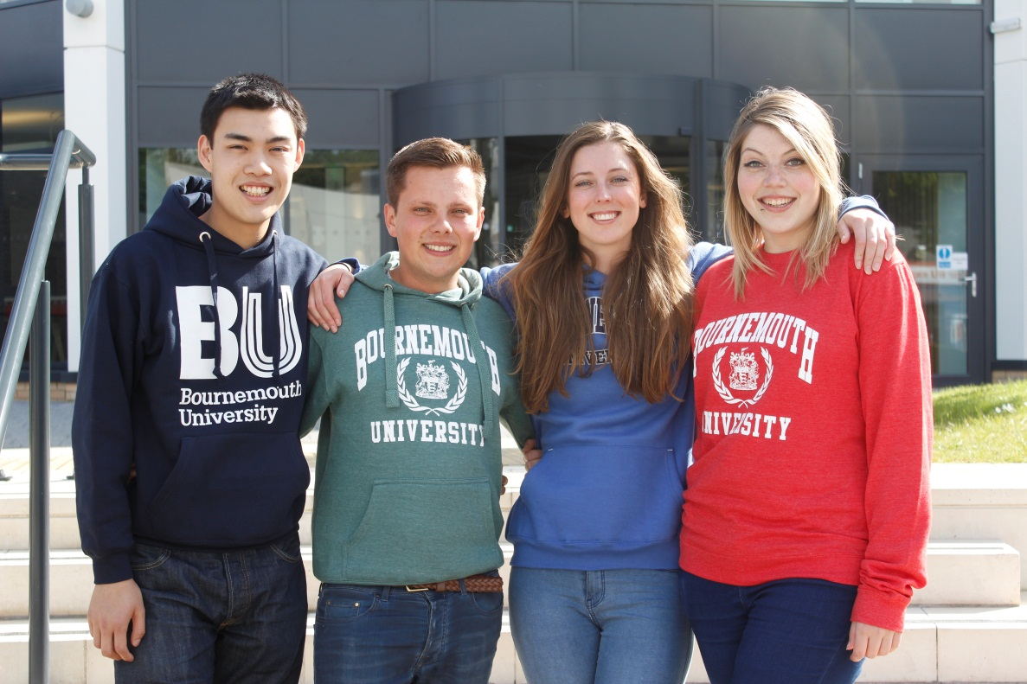
Image caption: BU’s SUBU Officers for 2015/16 (L-R): Jon Leung, Vice Presidents Activities; Reece Pope, Vice-President Welfare; Chloe Schendel-Wilson, President; Ellie Mayo-Ward, President Education

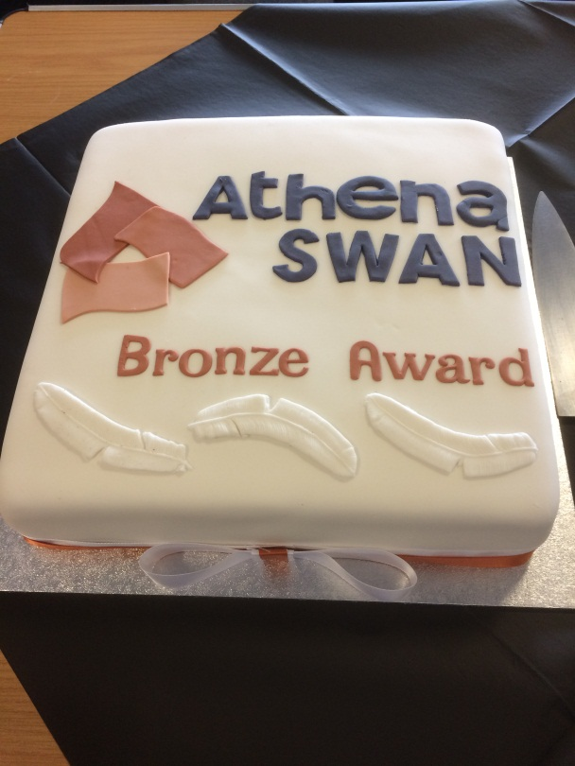
Image caption: A celebration was held in recognition of the work that went into achieving the Athena SWAN Bronze Award, which highlights our commitment to gender equality in higher education
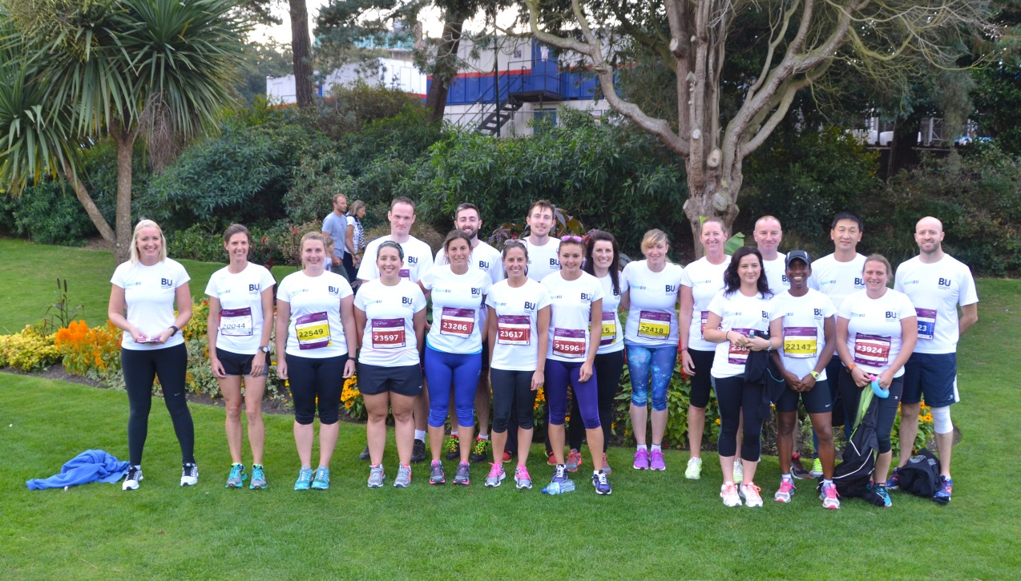
Image caption: A squad of BU runners took part in this year’s Bournemouth Marathon Festival. Crossing the finish line in style

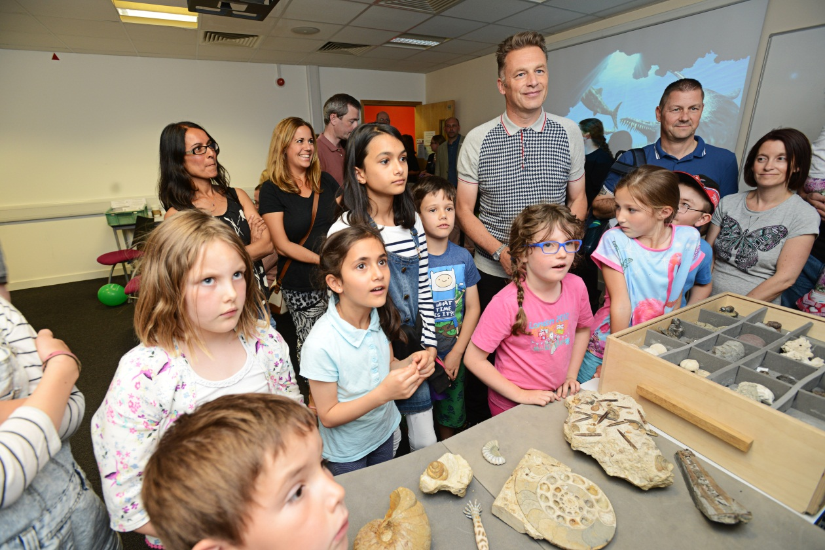
Image caption: BBC presenter Chris Packham was our guest speaker at the Festival of Learning 2015 where visitors of all ages enjoyed the events

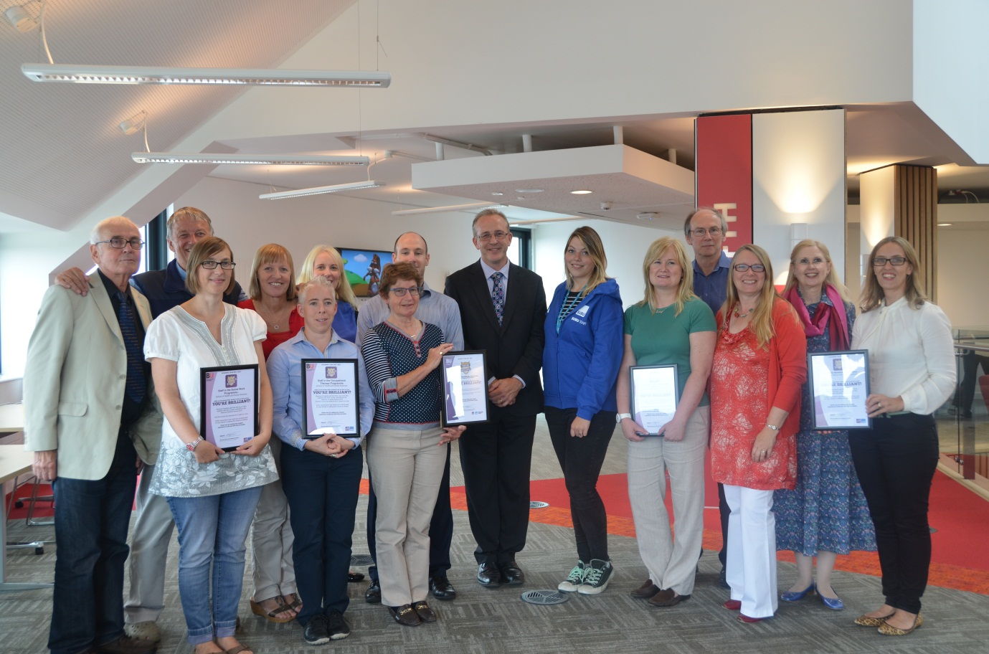
Image caption: BU’s Vice-Chancellor John Vinney held a celebratory event for courses with the highest levels of student satisfaction in the National Student Survey (NSS)

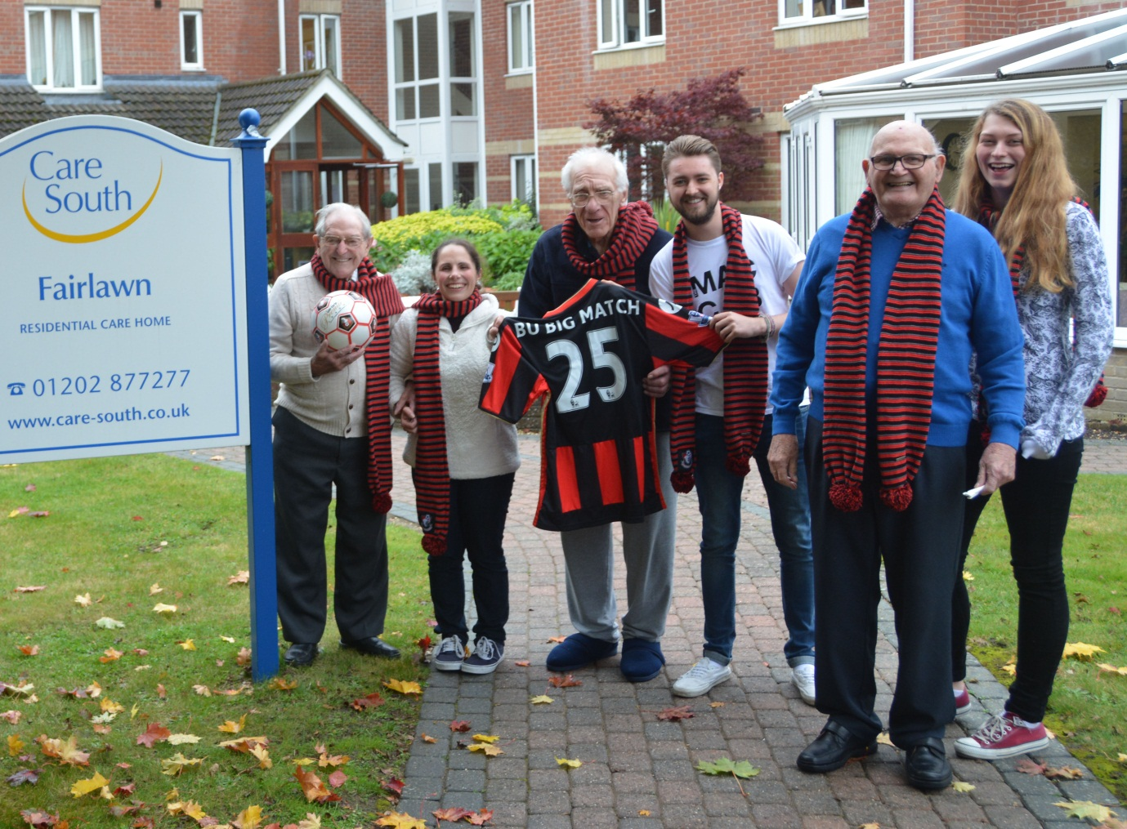
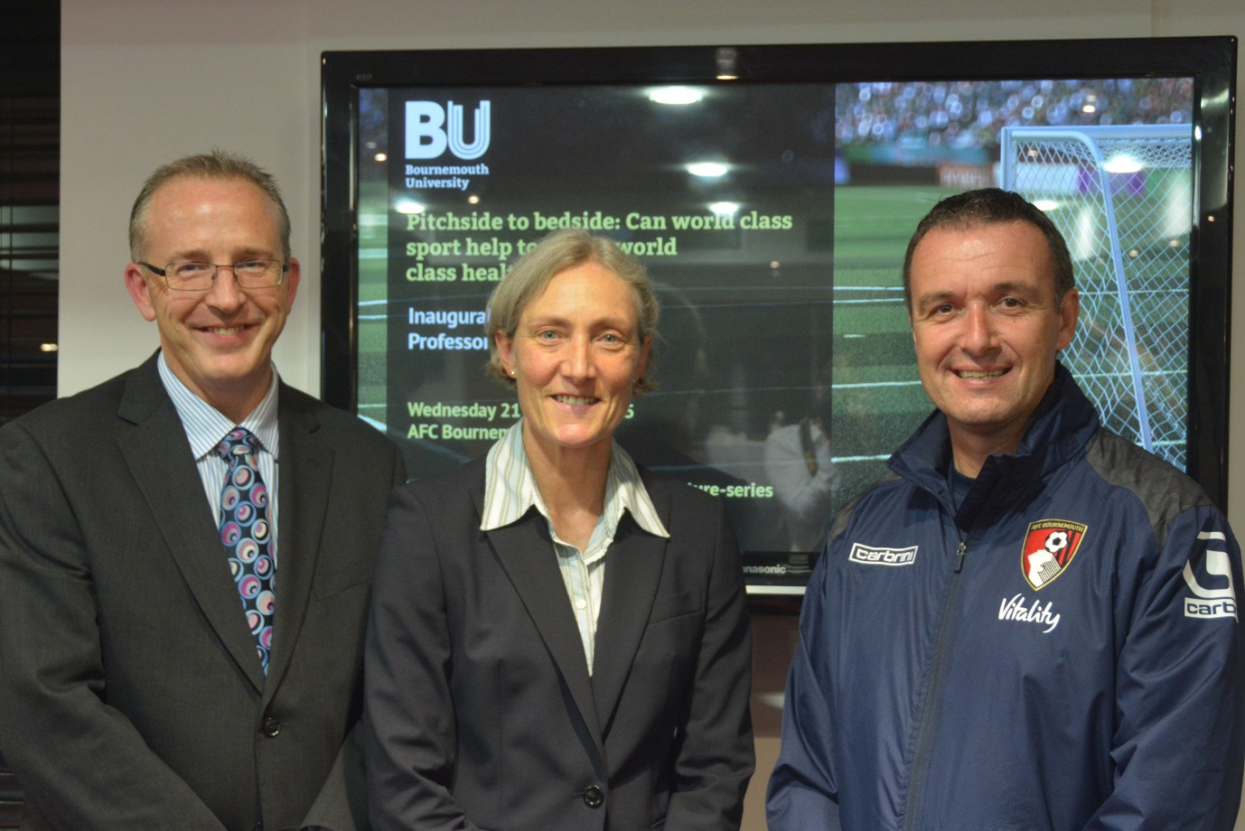
Image caption: The #BU Big Match celebrated BU’s partnership with AFC Bournemouth around the Bournemouth v Spurs match. A week of activity included a lecture by Professor Alison McConnell and SUBU volunteers linking up with the club’s charity partner Care South, to attend the match with residents from a local care home

[Heading fourteen] Dates for your diary

[Sub-heading] Café Scientifique
First Tuesday of every month
Explore the latest ideas in science and technology at Café Boscanova, 650 Christchurch Road, Boscombe

Cafescibournemouth.wordpress.com

[Sub-heading] Christmas Closure
The university will close at 1pm on Thursday 24 December and reopen on Monday 4 January 2016.

The vacation bus service will operate from Monday 14 December to Thursday 24 December. The service will not run again until Monday 4 January, when the term time service will be in operation.

Please check www.thebusforbu.co.uk for timetable information.

[Sub-heading] Vice-Chancellor’s Staff Awards
Thursday 26 November, Talbot Campus

An awards ceremony that recognises the achievements of our staff.

[Sub-heading] University Music Christmas Concert
Sunday 6 December, Royal Bath Hotel, 7pm

The University Big Band and Orchestras play an evening of festive favourites

www.bournemouth.ac.uk/music

[Sub-heading] Showcasing Undergraduate Research Excellence at BU (SURE) Conference
Wednesday 2 March 2016

SURE BU aims to identify and reward excellent research being undertaken by BU’s undergraduates, with a prize of a fully-funded Master’s course for the best overall contributor, among other prizes.

Find out full details at www.surebu.org.uk

[Sub-heading] Undergraduate Open Day
Saturday 21 November

Open day for prospective students www.bournemouth.ac.uk/ open-days

[Sub-heading] Graduate and Placement Fair 2015

Wednesday 11 - Thursday 12 November, Kimmeridge House, Talbot Campus Organisations will be on campus to offer insight into their placements, summer internships or graduate opportunities.

www.bournemouth.ac.uk/careers

[Sub-heading] Mike Warne Lecture 2016
24 February, Kimmeridge House, Talbot Campus

2016 marks the 10th anniversary of the annual Mike Warne lecture, a highlight in the marketing calendar for students and marketing professionals across Dorset. The event is jointly organised by BA Marketing Communications students and CIM Dorset.

www.regions.cim.co.uk/southwest/ home

[Sub-heading] Postgraduate Open Afternoon
Wednesday 25 November

An event for those interested in studying a postgraduate course at BU www.bournemouth.ac.uk/ pg-visit ESRC FESTIVAL OF SOCIAL SCIENCE Monday 7- Monday 14 November

The Festival offers insight into some of the country’s leading social science research and how it influences our lives
www.bournemouth.ac.uk/ esrc-fss

[Sub-heading] Service Excellence Conference 2016
Thursday 7 April, Kimmeridge House, Talbot Campus

A one-day conference on service excellence for all staff across BU – more details to follow

For more information about events at BU, please visit news. bournemouth.ac.uk/events or contact the Events Team on 01202 961018/buevents@bournemouth.ac.uk.

