InsideBU
Spring/Summer 2016

[Heading One] Message from John Vinney
Welcome to the latest edition of InsideBU – the magazine that shares some of the enriching and inspirational stories happening within the BU community.

The year started with BU being ranked in the Times Higher Education top 200 list of the most international universities in the world. This is great news and the ranking reflects the impact of a range of initiatives over recent years that follow from our Global BU strategy.

We’re committed to developing global talent and I’m very pleased we’re attracting high calibre students and staff from around the world. Many undertake research here which has an international impact, and we’re committed to an educational experience that combines internationalisation and employability for all our students.

This issue of InsideBU highlights how students and staff from across BU work together to ensure we’re at the forefront of teaching innovation, to create the best learning environment possible, combining excellent teaching with research and professional practice. On page xx you can read about BU’s Centre of Excellence in Learning, while on pages xx you can find out how working in industry on a placement has changed the way students approach their final year studies.

As always, there is a lot going on around the university and I encourage you to share your stories and successes at insidebu@bournemouth.ac.uk.

[Heading Two] News from around BU

[Sub-heading] BU on the rise again
BU has been ranked in the Times Higher Education top 200 list of the most international universities in the world. This accolade reflects BU’s increasing international reputation and the worldwide reach it has gained in recent years.

This announcement at the start of 2016 follows the rising trend seen in 2015 when BU entered the ranks of the top 500 universities in the world for the first time, according to the latest Times Higher Education World University Rankings. BU also rose in all three major UK university league tables in 2015 - the Complete University Guide, Guardian University Guide and The Sunday Times Good University Guide.

For more information, including the full list of the most international universities, visit www. timeshighereducation.com.

[Sub-heading] BU Festivals this summer
Festival of Learning, 25-29 June
BU’s biggest festival is back! There’s a range of free events open to the public, students and staff, kicking off with a family day on the Saturday. This year we’ll be celebrating and sharing our research with the BU community, so make sure you sign up.

Find out more at www.bournemouth.ac.uk/fol.

Festival of Design and Technology , 17-20 June
The annual Festival of Design & Technology showcases final year projects from students on Design, Engineering and Creative Technology courses. The exhibition is open to staff, students, businesses, schools and colleges to attend, and registration is open now online.
www.bournemouth.ac.uk/ festival.

BFX, 10 - 16 October
BFX celebrates and promote the visual effects, computer games and animation industry. From technical workshops for those in the industry, to family friendly events on the Saturday and Sunday, there’s something for everyone.

Find out about all of the events and book your tickets at www.bfxfestival.com.

[Sub-heading] Peer Assisted Learning
BU’s Peer Assisted Learning (PAL) is going from strength to strength. PAL encourages students to support each other and learn collaboratively under the guidance of trained students, called PAL leaders, from the year above.

PAL aims to help students adjust to university life, develop their independent learning skills and prepare for exams, among other things.

To highlight the importance of PAL in universities, the Association for Learning Developers in Higher Education recently published a special edition on the subject. BU’s PAL team – who won the Collaborative Team Award at the Vice-Chancellor’s Staff Awards 2015 – were successful in having their paper about PAL leaders developing key employability attributes through the scheme, published.

To read the paper, head to www.aldinhe.ac.uk. Find out more about PAL at: www.bournemouth.ac.uk/pal.

[Sub-heading] BU’s Student Charter
BU has launched a new Student Charter. This explains our promise to BU students and also – importantly – the commitment needed from them so we can fulfil that promise.

Studying at university is a mutual, active partnership and students are a very important part of that partnership. By working together professionally and respectfully we can achieve our goals together, so please read the charter to understand how that works. Following this means students will get the best out of their experience at BU.

Read the Student Charter online: www.bournemouth.ac.uk/student/rules.

[Sub-heading] National Teaching Fellowship Scheme
The National Teaching Fellowship Scheme celebrates excellent practice and outstanding achievement in learning and teaching in higher education. It recognises, rewards and celebrates individuals who have made an outstanding impact on student learning and the teaching profession.

BU is encouraging more of our outstanding teaching staff to have their achievements recognised by the scheme. Internationally recognised, gaining a Fellowship is just the beginning – Fellows continue to work to enhance learning and teaching in their institutions. BU is fortunate to have two National Teaching Fellows, including Professor Stephen Tee and Dr Debbie Holley.

Stephen says of the scheme: “Gaining my Fellowship was highly significant for me as it championed my work to improve the student experience and enhance teaching and learning in higher education. It opens up so many new avenues and I’d encourage others to pursue this opportunity.”

The Centre of Excellence for Learning has an annual call for BU Learning and Teaching Fellowships (BULTF). The BULTF award is intended to demonstrate BU’s commitment to valuing education excellence based on a combination of research and professional practice.

If you’re interested in developing your profile as an excellent educator in this way, find out more at: www.bournemouth.ac.uk/ cel-fellowships.

[Sub-heading] BU research project wins Times Higher Education Digital Innovation Award
BU research which enables children with disabilities to take part in artistic activities won in the Outstanding Digital Innovation in Teaching or Research category at the Times Higher Education (THE) Awards.

The SHIVA (Sculpture for Healthcare: Interaction and Visual Art in 3D) software enables children with physical and learning disabilities to create objects using eye gaze or touchscreen technology, before 3D printing the finished result.

It is currently being used by pupils at Victoria Education Centre and the team from BU’s National Centre for Computer Animation now hope to develop the SHIVA prototype further, for use in more schools and with able-bodied children.

[Sub-heading] SUBU President - Chloe’s Column
In SUBU, we are incredibly proud of our completely unique partnership approach with BU, which has the student experience at the heart of everything that we do.

The students at BU play an integral part in ensuring that their learning and teaching is the best it possibly can be – we pride ourselves on having what we believe is the best academic representation system in the world. There is one rep for every twenty students here at BU, and they work with various students and staff, to ensure that the learning and teaching at BU is also world leading.

Initiatives such as academic advisors, anonymous marking and video recording lectures, are huge changes across the university that are underway because of the relationship that the students and staff have. I feel incredibly proud to have been both a student and then Student Union President at somewhere so unique.

[Heading Three] Next generation technology for the next generation of learners
BU’s Professor Stephen Heppell is a world-renowned expert on using digital technology in the classroom.

A ‘thinker in residence’ on the subject at a college in Australia, he’s part of the Education Technology Action Group and has just completed a government-commissioned report about it. Here he gives InsideBU a snapshot of his latest thinking.

I’ve got about 35 years of very clear evidence of the impact on learning that technology can have and right now I would probably summarise all this with four statements:

1.Just as with pencils and paper, it is what you do with technology that counts. It is not just about equipment, ever.

2. When using digital technology, we’ve seen children show really quite remarkable capabilities far earlier than the school system expects. By and large the current education system is very unambitious for children and as a result they get bored, are under-stretched and disengaged. That is a tragedy but we can turn it around very quickly if we do the right things early enough.

3. Education has been very poorly researched. We are just starting a project exploring what is the ideal food to eat before an examination. With 900 million children doing tests every year around the world it’s scandalous that this work hasn’t been done. Every athlete knows exactly what to eat before their final event. Kids should know that too, and there is a lot more they should be told as well.

4. And finally, whenever the learners are given an opportunity to research and explore what might make learning better, they discover excellent new approaches, they become dramatically more engaged and their own reflective practice propels them to far better results.

A few schools, of course, still ban phones and regard writing on the walls as heinous, which is a shame for their children’s progress. Today though, even Eton has added writeable walls and desks in their latest school improvement project; this stuff is complex, but it really works!

[Heading Four] Do more, learn more, achieve more

InsideBU finds out how taking part in extra activities can enhance your degree and open up your world to new experiences.

The BU Student Development Award is a great way for our undergraduate students to showcase skills to employers. There are over 100 activities to get involved with to earn points towards your award and you’re probably already doing some of it. Maybe you’re a sports, music or SUBU volunteer, taking part in careers workshops, involved with the Languages@BU community, or work as a BU student ambassador. There’s opportunities for everyone.

In your e-portfolio you’ll share your activities and details of the skills you’ve developed, and the annual award ceremony – sponsored by local organisations – is a great networking opportunity. You can apply at any time and, if you’re really driven, can complete the award within a year.

The Postgraduate Development Award supports our vibrant postgraduate community. Away from your academic studies, you’ll be encouraged to focus on the skills that will be of most use to you. It’s also a great opportunity to meet new people with various specialisms and demonstrate your commitment to your development.

You’ll be awarded points for participating in activities, and your reflective writing will form your online portfolio, showcasing everything you’ve done towards your award.

Sign up and complete your skills audit in myBU or contact the Graduate School - pgmasters@bournemouth.ac.uk.

BU created the Researcher Development Programme with the aims of enhancing your employability and improving your performance in relation to your research.

You’ll have the opportunity to attend over 70 workshops, facilitated by the Graduate School, and additional subject-specific training is provided within each of the faculties. Successful participants will receive a certificate at graduation, supplementing your Research Degree Certificate - so as well as the benefits you’ll have gained from engaging with this process, you’ll have something tangible to show future employers relating to your achievements and development at BU.

[Heading Five] Co-creation generation
Co-creation is at the heart of what we do at BU – students, researchers and often industry working together, learning from each other and producing high quality academic work with societal impact.

[Sub-heading] Highcliffe Castle
A group of business students have been working on an ambitious project for local visitor attraction, Highcliffe Castle. They prepared a £2.5 million Heritage Lottery Funding bid to continue restoring this 19th century Grade I listed building. As part of the project students are investigating how apps are used at historical sites and have designed a mobile app so visitors to the castle can see historical details and stories, whilst helping them navigate the site. It’s hoped this will be of use at other sites in the future. BU lecturer and project management specialist Karen Thompson says: “Working with local businesses and communities on practical problems is valuable for developing students’ confidence and business skills.”

[Sub-heading] A midwife’s guide to working with the media
Midwives work with the media in numerous scenarios: reporting on clinical experiences, sharing the latest learning through chat forums and social media, writing reflective pieces for journals and blogs and offering clinical insights for television researchers. “We’re producing ‘A midwife’s guide to working with the media’, which we hope will inspire as many midwives as possible to engage with the media,” says student Sian Ridden. “We hope it removes barriers, answers questions and acts as a step by step guide to support them, whilst upholding the Nursing and Midwifery Council’s values.” Sian’s mentor Professor Vanora Hundley says: ““I’ve really enjoyed working with Sian. She brought a unique perspective to the project through her previous experience as a journalist prior to studying midwifery at BU.”

[Sub-heading] Student environment research team project: The Purbeck Heath Survey
Five BU Ecology & Wildlife Conservation undergraduates led 25 students from four other universities in a survey of heathlands across Purbeck. The work was in collaboration with the National Trust and RSPB and shed new light on how wild plants and pollinators are impacted by cattle and deer grazing on heathlands. The BU students were mentored by Dr Anita Diaz and Dr Liz Franklin and led their sub-teams in field surveys and data analysis, as well as coordinating the practical logistics of staying at a self-catered field centre. This gave the students opportunities to hone a wide range of employability skills. “Learning through co-creation between students, staff and practitioners is something BU is a leading light on,” said Anita. “The students learnt a lot about ecology and leadership skills.” The results, which showed grazing may reduce pest invasions and benefit bumblebee populations, were presented at the British Ecological Society Annual Conference.

[Sub-heading] Increasing awareness of food poverty
Faculty of Management students took on the weighty tasks of raising awareness of food poverty, in a co-creation project with Bournemouth and Poole Sustainable Food City Partnership. The team of five MSc Marketing Management students led events and activities under their mentor Dr Elvira Bolat, including quizzes, a smoothie bike and even tips on growing your own fruit and vegetables. Families with young children and people of all ages and nationalities came along and learnt that food poverty is a complex issue – not just the quantity, but also the quality of food – and that a developed country like the UK faces the food poverty problem daily. Student Anh Nguyen says of the project: “The events gave me confidence to talk to people, and to practice my marketing skills. It was great to work with my tutor Elvira and to do something else beyond my classes.”

[Heading Six] The Centre for Excellence in Learning
The government, parents and students have increasingly high expectations of university teaching and learning. InsideBU finds out more about the Centre for Excellence in Learning (CEL), a leading light in the sector.

CEL supports students to get the best out of their studies and time at BU and provides staff with practical tools and training to inspire excellent teaching. Crucially, all practical support is underpinned by high quality pedagogic research.

[Sub-heading] Media and Digital Literacies
This area builds on the expertise found in BU’s Centre for Excellence in Media Practice (CEMP), where innovation in learning has always been a priority. Their particular focus is on developments in technology and how these can benefit the learning process.

CEMP are currently working with Samsung and a local academy in Portland to explore the use of technology in learning, by combining their expertise and applying it in educational and community settings.

[Sub-heading] Practitioner Enquiry
Learning is a lifelong process and continues within the workplace and throughout professional life, which is reflected in this research theme.

Jenny Moon is working with Football Association Coach Educators to support and inform their approach to reflection in coaching. In the longer term, this work is likely to influence the education and development at all levels of FA coaching. The work is based directly on Dr Moon’s research into the benefits of reflective practice in education and professional development.

[Sub-heading] Higher Education Dynamics
CEL’s final area of research explores the wider student experience, higher education policy and the impact of widening participation.

BU’s Fair Access Research project takes an interdisciplinary approach to exploring the success and experiences of students from a widening participation background. Combining knowledge of academics, professional staff and SUBU, the project is likely to produce influential results.

CEL is an important part of BU’s preparations for the anticipated national Teaching Excellence Framework, demonstrating our quality and commitment to effective learning.

[Heading Seven] Technology Enhanced Learning
The rapid rate of change in technological education learning tools - and introducing these into academics’ everyday working lives - is becoming increasingly challenging. InsideBU learns what BU is doing to support students and staff in an ever-changing technological environment.

As a starting point, the Centre for Excellence in Learning (CEL) has produced a Technology Enhanced Learning (TEL) toolkit.

This provides easy access to support documents and helps identify good practice that already exists in BU – promoting and showcasing current innovative strategies and thought leaders in this area. It also gives information on current BU technology and other recommended technological tools.

The TEL Toolkit has been designed around TEL’s major pedagogic themes:

Flipped classroom A reversal of traditional teaching where students access new material outside of class, usually via reading or lecture videos

Blended Learning A programme of learning in which students learn through a variety of mediums and methods

Assessment An on-going process of establishing and measuring the expected outcomes of student learning and then assessing achievement against these

Co-creation Where students and staff work together as partners to develop and deliver new learning materials and programmes

Feedback Ensuring that feedback provided to students is timely, consistent, studentfriendly and makes the best use of available technology

Engagement Focuses on how we can improve student learning results by improving motivation, interest and curiosity in the learning provided

The toolkit includes

• An explanation of, and support for, major pedagogic themes
• The what, why and how of BU supported learning tools
• How to develop your academic career
• ‘Get Inspired’ page – find out something new
• TEL blog - where all contributions are welcome
• Access to case studies, videos and other supported material
• New material and ideas in the Higher Education field

This showcases how BU’s academics use different methods to enhance both their students’ learning experience as well as their own. The site also contains feedback from BU students on what tools work best for them and why.

Find out more and access the TEL toolkit at www.bournemouth.ac.uk/tel-toolkit

[Heading Eight] Kickstarting careers
All our students are offered a work placement as part of their course. InsideBU hears from four final year undergraduates about the impact their industrial experience has had on their final year of learning.

NAME: Ieva Severinaite
COURSE: BA (Hons) Public Relations
PLACEMENT EMPLOYER: Airbus
JOB TITLE: Internal Communication & Community Engagement Assistant

“My role covered everything imaginable in ‘communications’ including events and media relations. The skills I’d developed on my course were invaluable, especially writing press releases, giving presentations and campaign planning. My biggest challenge - and greatest highlight - was being project lead for TeenTech, a nationwide event promoting science and engineering careers to students. The value of learning on the job cannot be underestimated. Coming back to university was a bit of a shock to the system! Juggling multiple assignments and not being able to ‘switch off’ at the end of the day was difficult to start with – but on the bright side, having flexibility with my time has been a welcome change. I dedicate study hours to each weekday so I can enjoy the weekends without worrying about progress on assignments. And I’ve become addicted to ‘to-do’ lists! My learning experience has allowed me to build a shining CV, define my career aspirations, and given me the skills and confidence to pursue them.”

NAME: Stephen Moss
COURSE: BA (Hons) Business Studies - Strategic Human Resource Management pathway PLACEMENT EMPLOYER: IBM
JOB TITLE: ITS HR Implementation Co-ordinator, which later evolved into GTS Workforce Management Specialist Intern

“For me, the key difference between learning at university and on placement is your personal interest to learn new things versus how your actions impact the team and organisation. Coming back to BU has been good – it’s important to keep learning and developing academically. My placement was great and I learned so much in a practical environment, but my final year is allowing me to delve deeper into topics that I dipped into previously. Being organised on my placement has really helped with assignments - I go to the library from 9am - 5pm most days to emulate the structure of the working environment. Each year at BU has challenged me in new ways. Coming through those challenges has given me a real drive and confidence. I’ve got lofty ambitions for my career, so the experiences that I’ve had will help me achieve what I want.”

NAME: Fran Strange
COURSE: BSc (Hons) Sports Development and Coaching Sciences
PLACEMENT EMPLOYER: Active Dorset County Sports Partnership
JOB TITLE: Sports Development Officer

“I assisted two government-funded Sport England programmes – ‘Sportivate’ and ‘Satellite Clubs’ – to increase sport participation in Dorset, which was fantastic. I enjoy learning on a practical level, but my second year units really helped as I already had knowledge of government policies and an insight into how the sports industry is run and developed. Initially it was quite hard to start writing academically again when I returned to BU, but I’ve quickly adapted. Opportunities and contacts from my placement have strengthened my dissertation and improved my data collection for my case study of the ‘This Girl Can’ campaign. My placement year really stood out to me and I strongly believe it will stand me in good stead over other graduates, as I’ve already experienced working full-time in a related job.”

NAME: Valjo Kutt COURSE: BSc (Hons) Sports Management
PLACEMENT EMPLOYER: Frenchman’s Creek Beach & Country Club
JOB TITLE: Golf Operations Intern, promoted to Golf Operations Supervisor

“I loved every minute of my placement year! I learned so much about what it takes to run a five-star golf resort, including managing co-workers and caddies, and really grew as a person. My studies really prepared me to think outside the box and to handle delicate situations with care. Course units such as ‘Financial Appraisal for Sports’ gave me confidence working on the Club’s monthly budgets. Getting back into my studies has been challenging, especially as I hardly ever sat down on placement. Saying that, my confidence and time management has improved a lot - I’m not procrastinating as much as I used to, so I am getting my work done more easily than previously! I believe that with the combination of my degree and placement experience I am ready to take the next step in my career.”

[Heading Nine] Continue your success story
Did you know that Master’s students across the working age population earn an additional £9,000 per year compared to graduates? They take home average annual earnings of £40,000 per year, according to 2014 UK Graduate Labour Market Statistics.

Postgraduate study is very different from undergraduate. You really do have to be passionate about your subject to study at Master’s level, as you’ll be going into a lot more depth and developing niche subject expertise.

You will have a different dynamic with your lecturers and it’s a very different learning style.

Alice White returned to BU to study MA Post Production Editing. She says, “The MA is more about asking questions rather than seeking answers. It’s about taking the initiative to explore techniques and theories.”

Lowri Roberts also stayed at BU to study MSc Marine Archaeology. She describes how postgraduate study helped her develop: “Academically, I believe I have more initiative since starting my Master’s, as it is a much more independent style of learning than the undergraduate degree. I also attend any extra sessions organised by lecturers so that I can maximise my learning time and opportunities to gain more information or ask for help.”

[Sub-heading] Funding

• The government recently announced a new postgraduate loan scheme for September 2016, for taught Master’s study. The Student Loans Company managed loan will offer up to £10,000 (non-means tested), paid directly to students over three instalments during the academic year and will be available for English and EU students. You will repay your loan alongside any undergraduate loan, at 6% of your income over £21,000.

• BU graduates, staff and staff family members can get tuition fee discounts of up to 25%, in addition to scholarships from £2,000 to full fee waivers.

Find out more at www.bournemouth.ac.uk/ postgraduate

[Heading Ten] Top learning tips from BU to you

Finding ways to get what you want – and quickly – is often easier said than done. InsideBU asked staff from across the university to give their top tips on how student can get more out of their time here.

[Sub-heading] Centre for Excellence in Learning (CEL)
With student learning at the heart of CEL, the blog is the perfect place to learn about regular funding opportunities, seminars and workshops which are open to both staff and students, and much more. www.bournemouth.ac.uk/cel

[Sub-heading] Library and Learning Support (LLS)
myBU contains a wealth of information and resources including a Study Skills tab to help with revision, essay writing, exam preparation and presentations plus details about how to learn a new language. It also includes an online resources guide in the Library tab, specific to your subject area, and the myBU Help tab makes it even easier to find help submitting your assignments online. Download the myBU app which provides mobile friendly information and announcements about your unit and assessments.
www.bournemouth.ac.uk/student/mybu

[Sub-heading] BU’s Student Agreement
For helpful information about our rules, regulations and legal stuff
From accommodation to assessments and finance to transport – it’s all available in one, easy to read document.
www.bournemouth.ac.uk/students/help-advice

[Sub-heading] BU’s Student Agreement Research Knowledge & Exchange Office (RKEO)
Sign-up to the Undergraduate Research Assistantship Programme
Gain paid work experience and put the theory you’ve learned into practice - working on a research project led by an academic.
www.bournemouth.ac.uk/ura

[Sub-heading] Additional Learning Support
Not fully understanding instructions and questions, and the anxiety of not knowing where to begin, can often lead to putting things off until the last minute. This can be magnified for those with dyslexia or dyspraxia. Having a one-to-one tutorial can help to work through things in a way that’s helpful to you. Tutorials give you the opportunity to sit with a specialist tutor and unpick assignment briefings. You’ll gain confidence and learn about assignment structuring, research and writing skills. Find out the range of support ALS can offer you - www.bournemouth.ac.uk/als

[Sub-heading] IT Services
Follow BU IT Services on Twitter @BUITservices.
Keep up-to-date with all things IT related – hints, tips, advice – as and when it happens.
Log onto the IT Services website - itservices.bournemouth.ac.uk – to see live service updates, log and track jobs.

[Heading Eleven] “You’re brilliant!”
It’s not every day you’re called an “all round legend” at work. Or thanked for “going above and beyond”. Unless you’ve just been surprised with a SUBU ‘You’re Brilliant Award’.
The Awards are a chance for students to tell a member of staff they think they’re brilliant – and why.

Any member of staff can be nominated, from lecturers to catering staff, demonstrators to bus drivers. Nominations are accepted throughout the year and staff will be presented with their award wherever their normal place of work is – a lecture room, office, café – at a time when they least expect it. So if you think someone’s doing a great job, tell them!

[Sub-heading] David Biggins Most Outstandingly Brilliant Winner 2015 S
Staff can be presented with an Award at any time, but there’s one very special accolade that’s given to one member of staff at the annual Vice-Chancellor Staff Awards. The most recent winner of the ‘Most Outstandingly Brilliant Award’ went to David Biggins, a Lecturer in the Faculty of Management.

A few of the things students had to say about David included; “He goes above and beyond”, “he is supportive, inspiring and a brilliant tutor” and “nothing is ever too much trouble for him.”

Congratulations David!

[Sub-heading] Here’s what our students have to say about some of our fantastic staff…

[Sub-heading] Alex Otto
“Always makes the lectures and lab sessions interesting and engaging. If you’re struggling she gives advice and helps as much as needed. Has the best stories!”

[Sub-heading] Harry Manley
“His knowledge is incredible and he is very patient and understanding when teaching.”

[Sub-heading] Nivien Speith
“She is a very enthusiastic and helpful lecturer and demonstrator. She keeps everyone engaged in the subject and is always cheerful.”

[Sub-heading] Phillipa Gillingham
“For all the amazing support she has given our class over the last 3 years. She never turns anyone away – always willing to help.”

[Sub-heading] Kamila Kharebashvili
“She has gone out of her way to make us feel comfortable coming to a new country. She’s helped us form a community that feels like ‘home away from home’ and she is part of our family!”

[Sub-heading] Sonya Harvey
“She’s such a dedicated member of staff and supports the students so well. She is always available whenever students need help”.

[Sub-heading] Ashley Woodfall
“He’s awesome! Fun and interesting lecturer who engages with people.”

[Sub-heading] Brenda Masters
“Thank you so much for constantly being there for each and every one of us over the last three years. It means the world to us.”

[Sub-heading] Phillippa Tarry
“We’d like to thank Phillippa for being a wonderfully consistent and conscientious Student Liaison Coordinator. When we faced a problem outside of office hours, she helped us so quickly that we didn’t even have time to panic!”

[Heading Twelve] Oscar 2016 success for BU
InsideBU takes a look at how our graduates have worked on some of the biggest films of the last year – resulting in Oscar wins at the most recent Academy Awards.

Over the last year, graduates from the Faculty of Media & Communication have worked on some of Hollywood’s biggest blockbusters, many of which were nominated for the 2016 Oscars. These include Mad Max: Fury Road, Star Wars Episode VII: The Force Awakens, The Martian and The Revenant.

Wins for Inside Out in the Animated Feature category and Ex Machina in the Visual Effects category ensured that BU graduates were among those who went home clutching one of the famous gold statuettes.

Mark Ardington graduated from BA (Hons) Computer Visualisation & Animation in 1997 and took to the stage as a part of the team who worked on Ex Machina. Mark’s success follows that of fellow alumni Andrew Lockley, who won Oscars in 2011 and 2015 for his work on Inception and Interstellar respectively. This means BU graduates have been on stage collecting an Oscar in successive years for the first time.

Phil Spicer, Programme Leader for MA Digital Effects, is understandably delighted with this latest round of alumni success. “We’re very proud of our graduates who have forged careers in the visual effects industry,” he says. “Every year at this time, it’s an opportunity for us to celebrate the success of graduates who have worked on Oscar-nominated and Oscar-winning films.

“This year is no different as a number of these films have been worked on by BU graduates. Big congratulations are due to all of our graduates who have been involved in Oscarnominated and Oscar-winning films this year.

“Their talent and hard work is astounding, and it is a privilege for us to have helped shape and mould their futures in this way.”

[Heading Thirteen] We Meet...

BU’s Faculty of Media & Communication is home to a sector-leading Learning Development Team. They provide bespoke, one-to-one support to students, including critical reflection, academic writing and research. They work closely with BU’s Centre for Excellence in Learning to share best practice with other faculties.

[Sub-heading] Camila Devis-Rozental, Learning Development Tutor, Faculty of Media & Communication

Students come to us with a variety of issues, either academic or pastoral. We know that a settled student, who understands what they are doing and why, will succeed. So we work with them to determine their development needs and give them the tools or strategies to develop themselves.

We provide an inviting and stimulating environment for the students. Our desks have two screens and one is facing the student, so we can work together. We find this very useful and students really like it. For example if we are going through an essay and there are areas for improvement regarding referencing, we can support students on how to improve there and then, so that next time they can do it themselves.

[Sub-heading] Natalie Chung BA (Hons) Communication & Media
As an international student, I struggled with English writing from time to time. In order to improve an academic essay, my lecturer suggested I go and see Learning Development.

The lecturer and I had a good chat about my general problems in writing. She then asked me what I really wanted to say in the essay and my point of views on the topic, then showed me how to construct the sentences in the right way.

My advice for current students is to read more, speak more and write more. The more you read and speak, the more you understand how ‘proper’ English works. As an international student, please don’t just rely on the way you used to learn English. This is very awkward when used in academic writing.

[Heading Fourteen] By Day By Night
Emil Siwadi is an Operating Department Practitioner (ODP) who spends half his time lecturing and the other half working in operating theatres.

Being in practice gives you the chance to get involved with real-life situations. That’s why it’s good for me to work as well as lecture – I’m still learning every day and can bring these experiences into the classroom.

An ODP’s remit is incredibly varied and we work very closely with anaesthetists and surgeons. Before any operation we’ll prepare the anaesthetic room, checking and setting up drugs and equipment needed. We’ll then discuss any additional concerns for each patient on the operating list and ensure the paperwork is all correct before carrying out all of the safety checks. We directly assist with the induction and continuously monitor the patient’s breathing, circulation and pain throughout the operation.

In the operating room itself, we’re responsible for assisting the surgeon and take responsibility for the surgical instruments and equipment. We have to ensure everything is accounted for throughout the procedure. We’re an extra pair of eyes looking at the wider field of vision and that allows the surgeon to focus on the complex procedure.

Another vital element is recovery - this is the period immediately after the operation. Patients have just gone through a traumatic experience and it’s our job to assess how they’re doing after the operation, ensuring they can breathe for themselves and controlling any pain.

A huge part of this job is building relationships with the patients – we’re always speaking up on their behalf, making sure they receive the highest quality care. You might only meet them for 5 or 10 minutes, so you have to gain their trust quickly. For their own safety we need to get through the standard procedures really quickly whilst making them feel like we’ve got all the time in the world, which is a real skill.

As an ODP, there’s no ‘normal working hours’. You’re working in operating theatres which are open 24/7, 365 days a year. I actually really enjoy the unsociable hours as it involves emergency situations with people who need urgent surgery. I also like working as part of a small team who have a broad set of skills and it’s an exciting part of the job.

It’s an unusual job in that you’re doing something life changing for a patient, but they’ll be none the wiser; but the satisfaction comes from knowing you have the skills to help them.

[Heading Fifteen] Dates for your Diary

[Sub-heading] POSTGRADUATE OPEN AFTERNOONS
Wednesday 16 March
Wednesday 6 July
Events for those interested in studying for a Master’s degree at BU.
www.bournemouth.ac.uk/ open-days

[Sub-heading] SERVICE EXCELLENCE CONFERENCE
Thursday 7 April
Kimmeridge House
A one day conference on Service Excellence for all staff across BU.

[Sub-heading] UNDERGRADUATE OPEN DAYS
Saturday 11 June
Saturday 2 July
Open days for prospective students

[Sub-heading] CELEBRATE CONFERENCE 2016
Wednesday 13 – Friday 15 April
An opportunity for students to showcase their work to the wider academic community and external organisations
www.bournemouth.ac.uk/cel

[Sub-heading] STUDENT DEVELOPMENT AWARDS
Wednesday 4 May
This ceremony celebrates the hard work and commitment students have given to extra-curricular activities, alongside regular studies who have achieved the SDA award.

[Sub-heading] FESTIVAL OF DESIGN & TECHNOLOGY
Friday 17 - Monday 20 June
The latest product design, engineering and creative technology innovations at the student showcase for the Faculty of Science & Technology.

[Sub-heading] BANK HOLIDAYS
Good Friday Friday - 25 March
Easter Monday - 28 March
Early May bank holiday – Monday 2 May
Spring bank holiday – Monday 30 May
Summer bank holiday – Monday 29 August

[Sub-heading] BFX 2016
10-16 October
BFX celebrates and promote the visual effects, computer games and animation industry www.bfxfestival.com

[Sub-heading] CAFÉ SCIENTIFIQUE
First Tuesday of every month
Explore the latest ideas in science and technology in Café Boscanova, 650 Christchurch Road, Boscombe
http://cafescibournemouth.wordpress.com

[Sub-heading] FESTIVAL OF LEARNING
Saturday 25-Wednesday 29 June
BU’s biggest festival is back, with a wide range of free events open to the public, students and staff. There’s something for everyone!
www.bournemouth.ac.uk/festivals

[Sub-heading] CREATIVE TUESDAYS
Every Tuesday in the Atrium Art Gallery Balcony Lounge
A weekly drop-in between noon and 2pm for anybody that would like to knit, sew or make/create- drawings, arts and crafts.

[Heading Sixteen] #BUProud Gallery

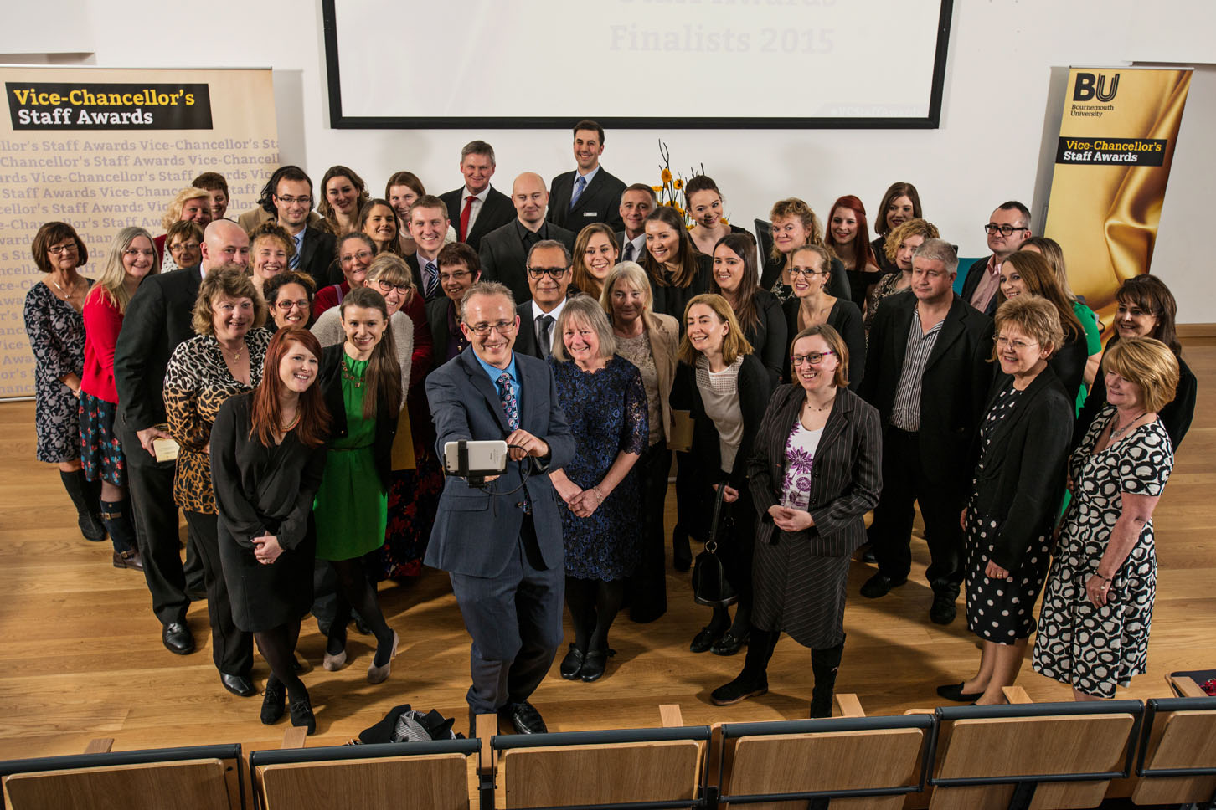

Image caption: The annual Vice-Chancellors Staff Awards reflects the outstanding work of our staff over the previous academic year, and to recognise and celebrate their achievements.

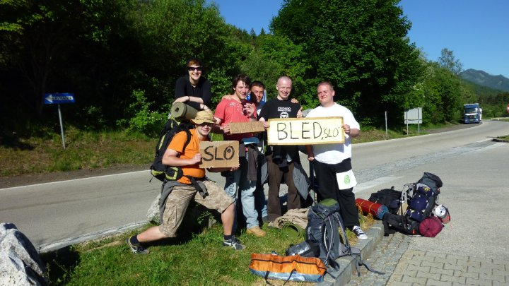

Image caption: Dr Michael O’Regan won the BU Research Photography Competition with his image, entitled Hitchhiking Culture, which represents his research into the hitchhiking culture in Europe.

Image caption: Jack and his owner Carolyn Atherton, who support students with additional learning needs at BU received an award from Caring Canines in recognition of their work

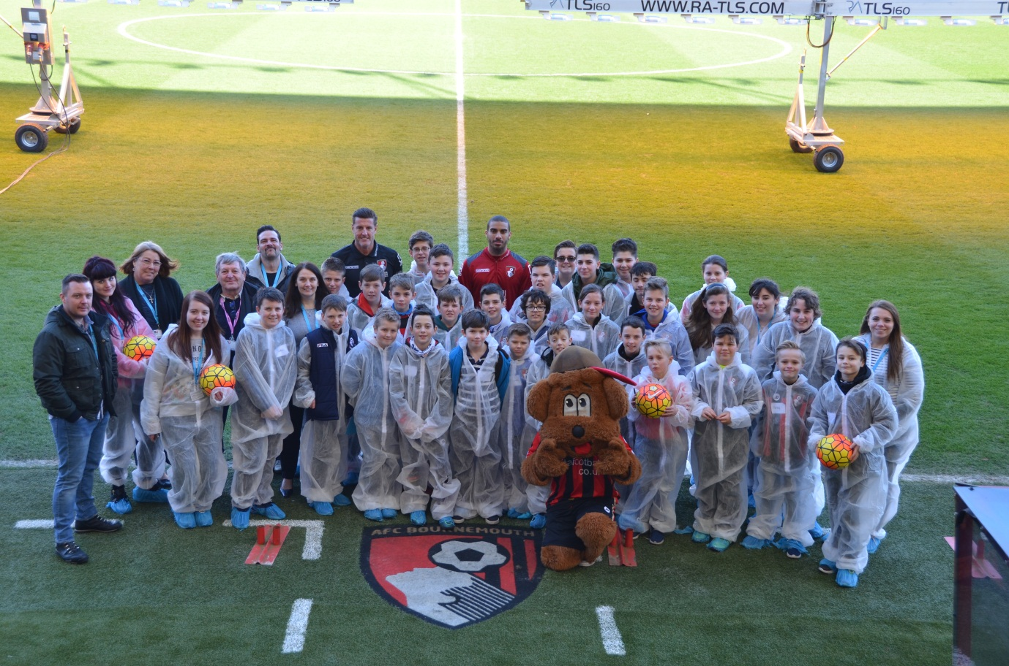
Image caption: Staff and students from BU staged a whodunnit day for the Junior Cherries, AFC Bournemouth’s young football supporters club. Using forensic science skills the Junior Cherries had use the evidence to find out who kidnapped AFC Bournemouth’s mascot Cherry Bear.

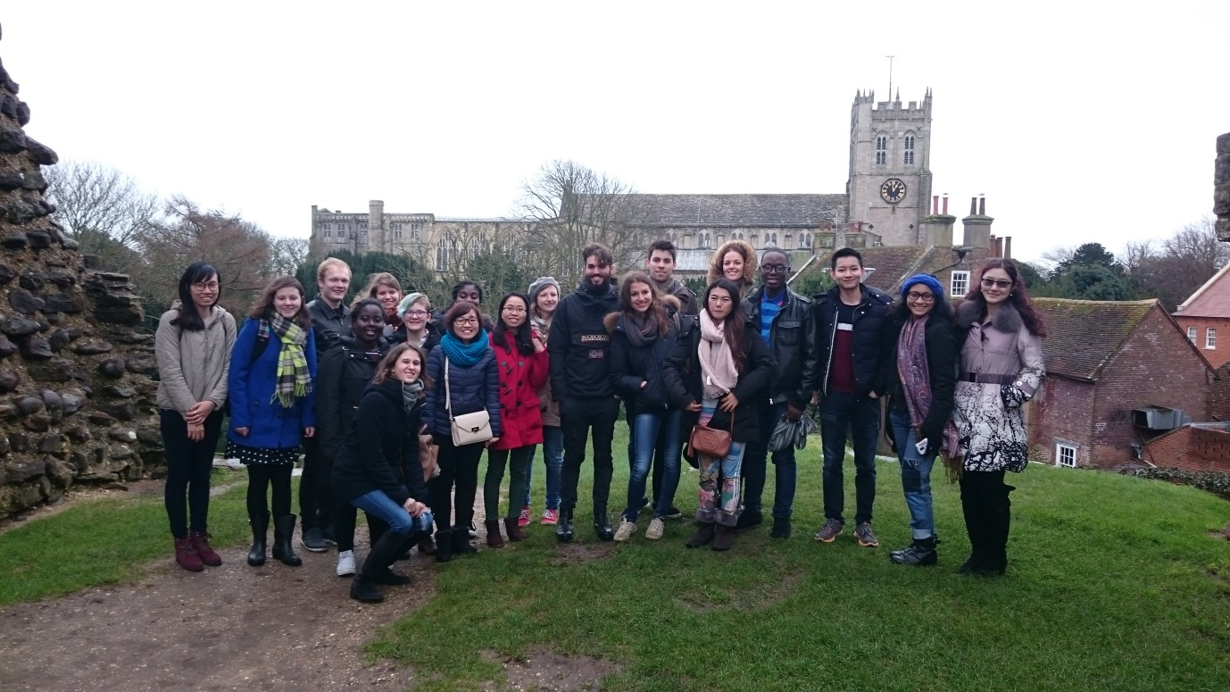
Image caption: Global Buddies – a scheme that matches new students with a Global Buddy of a different nationality – met up for a social event in Christchurch where they enjoyed a traditional English breakfast and a walking tour of the sights

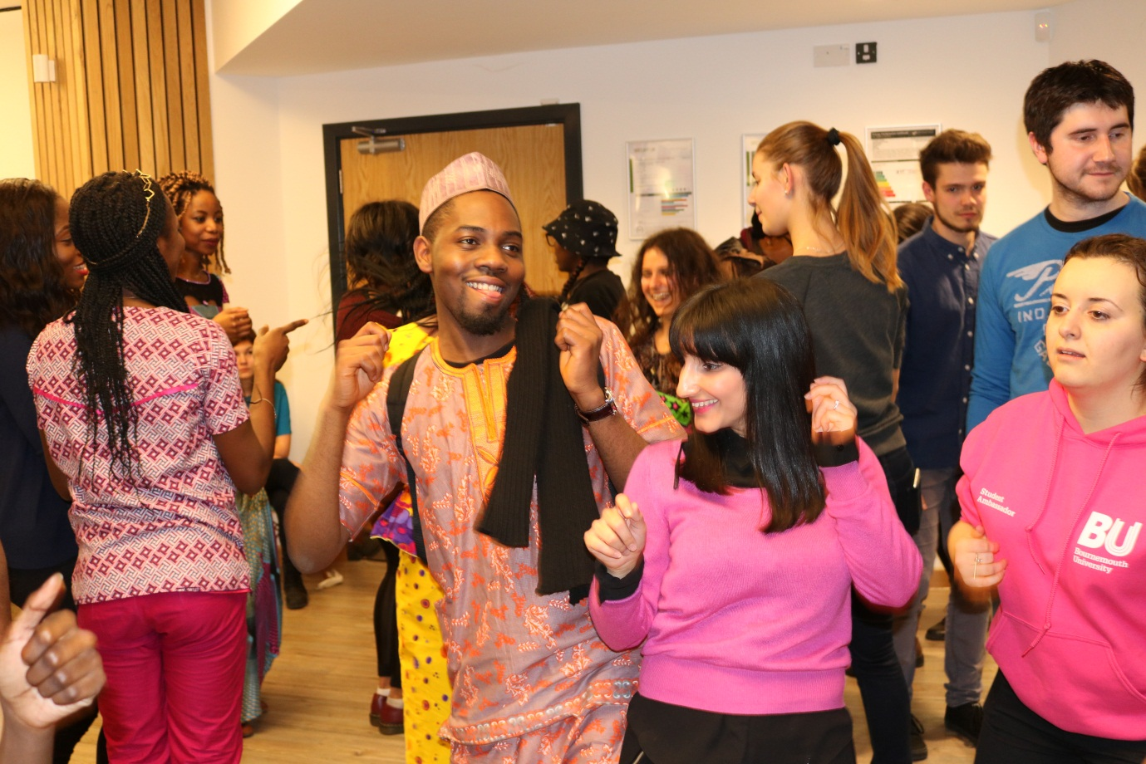

Image caption: SUBU’s One World Day brought together hundreds of students to celebrate the rich diversity of cultures at BU. There were talks, performances, dance classes and food, all provided by SUBU’s huge range of cultural societies.

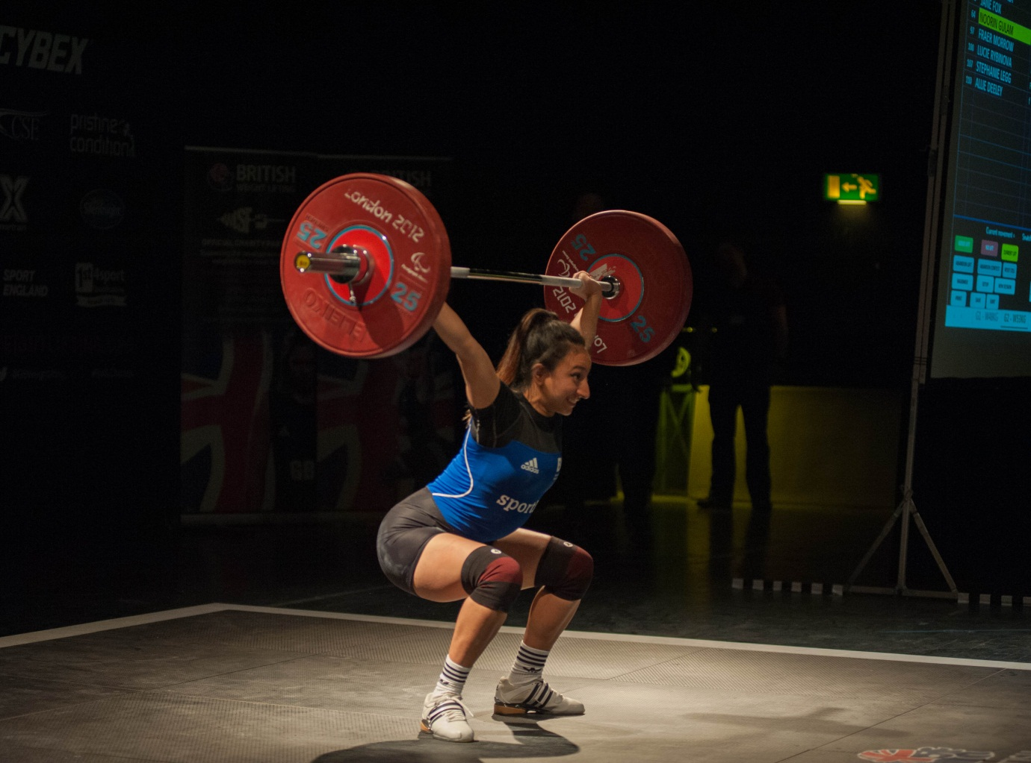

Image caption: BU sports scholar Noorin Gulan won the weightlifting gold medal in the English Senior Championships in the 54kg class.

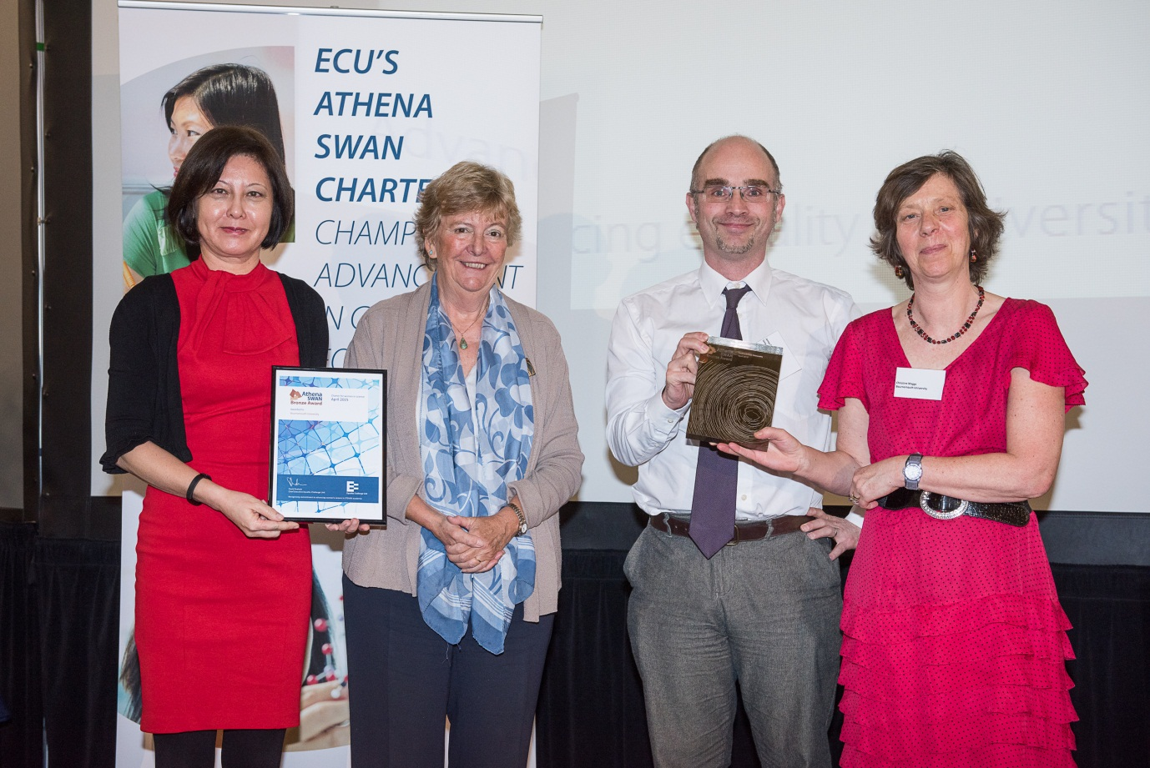

Image caption: BU received the Athena SWAN Bronze Award, in recognition of our commitment to tackling gender inequality in higher education.

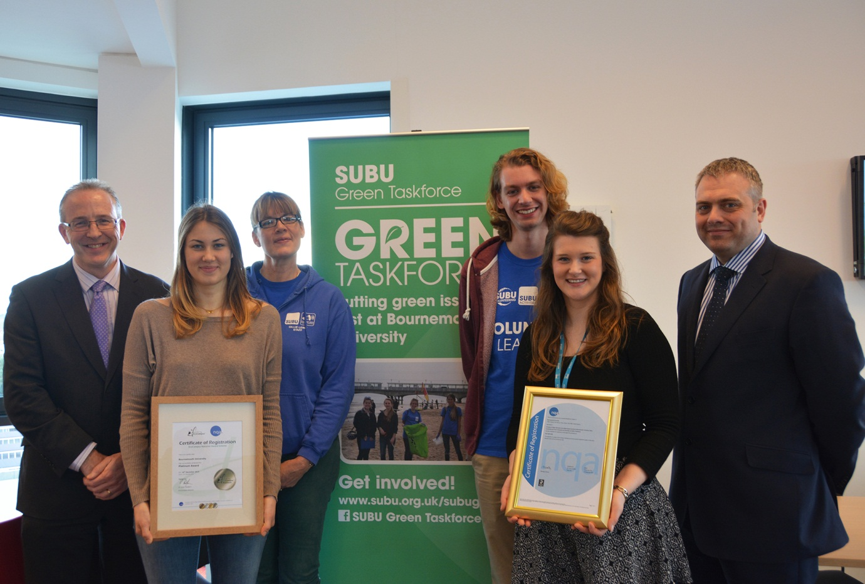

Image caption: BU celebrated achieving the EcoCampus Platinum and ISO41001 certification- the highest accolade we can achieve which demonstrates excellence in sustainability

